22

CO

in the atmosphere would

2

remain there for a long time and

would continue to exert a warming

effect. Model projections show how

atmospheric CO

concentration

2

(a), surface air temperature (b),

and ocean thermal expansion (c)

would respond following a scenario

of business-as-usual emissions

ceasing in 2300 (red), a scenario

of aggressive emission reductions,

falling close to zero 50 years from

now (orange), and two intermediate

emissions scenarios (green and

blue). The small downward tick

in temperature at 2300 is caused

by the elimination of emissions

of short-lived greenhouse gases,

including methane. Source: Zickfeld

et al., 2013

Clim ate Change

begin to cool because the excess

temperatures and the ocean to

take a long time for surface air

were to suddenly stop, it would

If global emissions

figure 9.

If emissions of CO

stopped altogether, it would take many thousands of years for atmospheric CO

to

in the future, widespread effort

2

2

return to “pre-industrial” levels due to its very slow transfer to the deep ocean and ultimate burial in ocean

will be undertaken that utilises

sediments. Surface temperatures would stay elevated for at least a thousand years, implying a long-term

such technologies to remove

commitment to a warmer planet due to past and current emissions. Sea level would likely continue

CO

from the atmosphere and

to rise for many centuries even after temperature stopped increasing

[Figure 9]

. Signiﬁcant cooling

lower its atmospheric concentra-

would be required to reverse melting of glaciers and the Greenland ice sheet, which formed during past

tion, thereby starting to reverse

cold climates. The current CO

-induced warming of Earth is therefore essentially irreversible on human

CO

-driven warming on longer

2

timescales. The amount and rate of further warming will depend almost entirely on how much more CO

timescales. Deployment of such

2

humankind emits.

Scenarios of future climate change increasingly assume the use of technologies that can remove green-

house gases from the atmosphere. In such “negative emissions” scenarios, it assumed that at some point

2

2

technologies at scale would

require large decreases in their

costs. Even if such technological

ﬁxes were practical, substantial

reductions in CO

emissions

2

would still be essential.

would require thousands of years to cool and return to the level in the pre-industrial era.

No. Even if emissions of greenhouse gases were to suddenly stop, Earth’s surface temperature

to the conditions of 200 years ago?

20

stopped, would the climate return

If emissions of greenhouse gases were

n Q& A

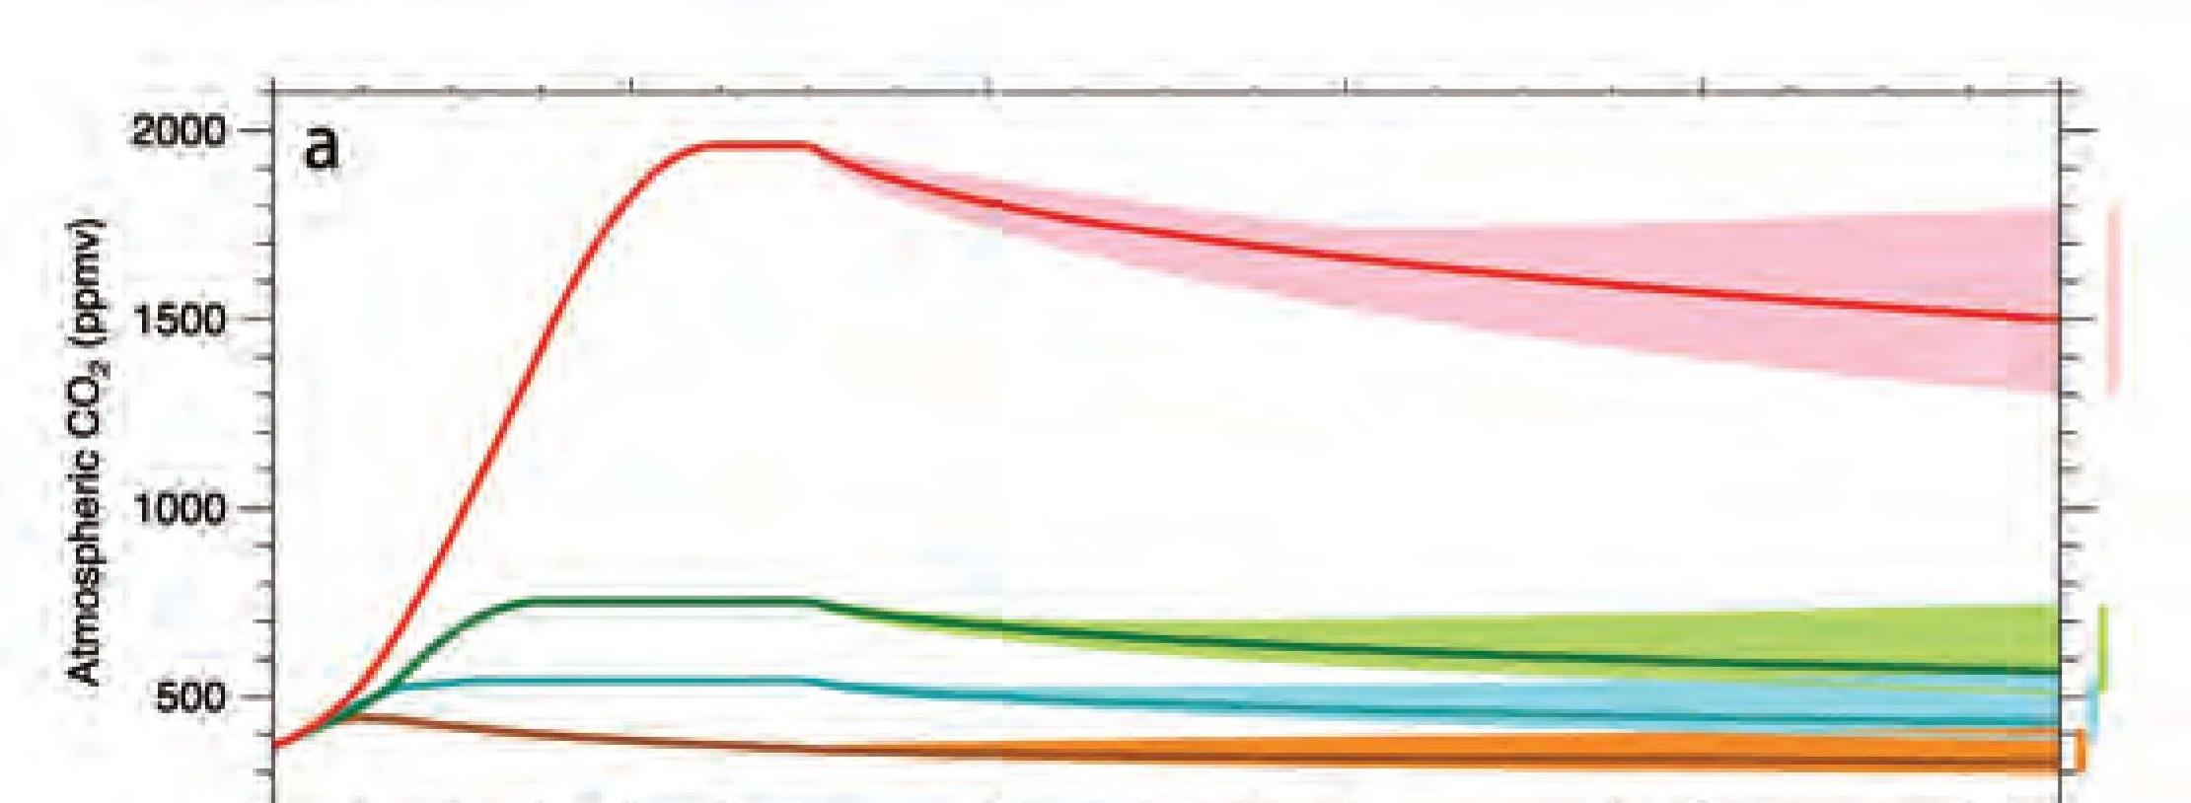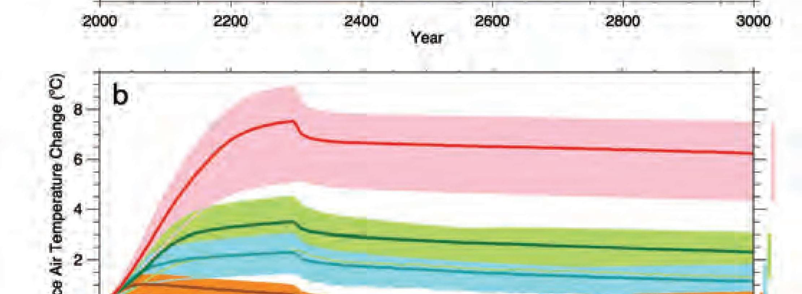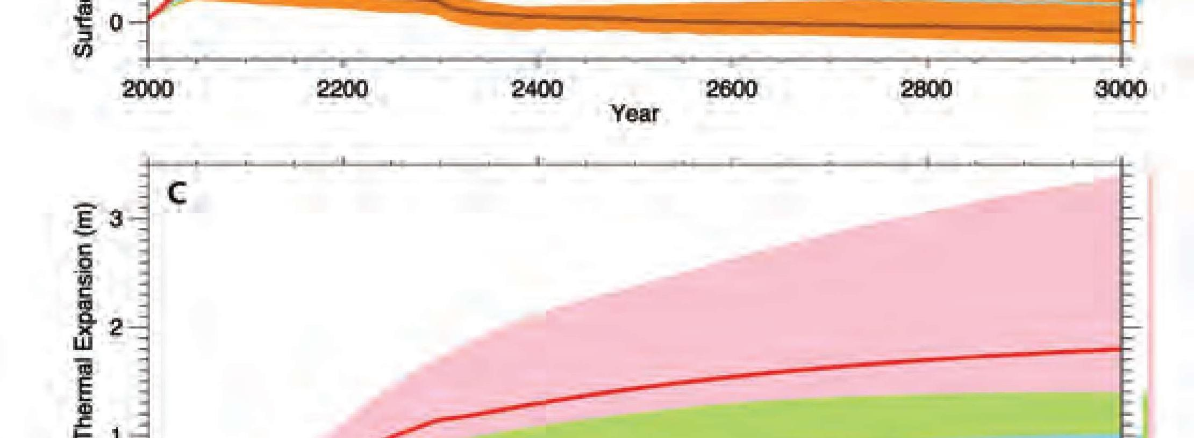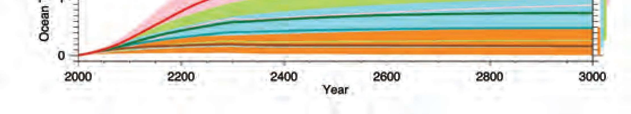

23

Evidence & Causes 2020

and its uncertainties, is offered as a basis to inform that policy debate.

either past or future. Our description of the science of climate change, with both its facts

in many cases those communities that are most vulnerable control few of the emissions,

global population as a whole. The options have to be discussed at a global scale because

options, to decide what is best for each group or nation, and most importantly for the

capacity to adapt. There is an important debate to be had about choices among these

options. Different nations and communities will vary in their vulnerability and their

risks, attractions and costs, and what is actually done may be a mixture of these different

some of the climate changes that would otherwise occur. Each of these options has

as possible; or they can seek as yet unproven “geoengineering” solutions to counteract

damage, and suffering that arise; they can adapt to actual and expected changes as much

magnitude of climate changes; they can wait for changes to occur and accept the losses,

production and usage in order to limit emissions of greenhouse gases and hence the

options) in response to this information: they can change their pattern of energy

Citizens and governments can choose among several options (or a mixture of those

human activities and infrastructure are expected.

but increases in the extremes of climate that can adversely affect natural ecosystems and

remains a range of estimates of the magnitude and regional expression of future change,

unabated, future changes will substantially exceed those that have occurred so far. There

activities. Further climate change is inevitable; if emissions of greenhouse gases continue

change is almost certainly due to emissions of greenhouse gases caused by human

are still increasing rapidly, that climate change is occurring, and that most of the recent

evidence that the concentrations of these gases in the atmosphere have increased and

changes in the amounts of greenhouse gases cause climate changes. It discusses the

This document explains that there are well-understood physical mechanisms by which

Conclusion



24

Climate Change

2020 Edition.

the Ralph J. and Carol M. Cicerone Endowment for NAS Missions for supporting the production of this

The Support for the 2014 Edition was provided by NAS Endowment Funds. We offer sincere thanks to

Support

Research, University of Wisconsin

John Kutzbach (NAS), Center for Climatic

■

Andrew Watson FRS, University of East Anglia

■

Dynamics Laboratory

Gabrielle Walker, Journalist

■

Isaac Held (NAS), NOAA Geophysical Fluid

■

Emily Shuckburgh, British Antarctic Survey

■

Physics, Imperial College London

Joanna Haigh FRS, Professor of Atmospheric

Center

■

Gavin Schmidt, NASA Goddard Space Flight

■

Sciences, University of Cambridge

Harry Elderﬁeld FRS, Department of Earth

University of Cambridge

■

John Pyle FRS, Department of Chemistry,

■

Academy of Engineering

John Pendry FRS, Imperial College London

■

Alec Broers FRS, Former President of the Royal

■

Geosciences, Pennsylvania State University

for Atmospheric Research

Jerry Meehl, Senior Scientist, National Center

■

Richard Alley (NAS), Department of

■

approved by the Royal Society and the National Academy of Sciences:

The following individuals served as reviewers of the 2014 document in accordance with procedures

Reviewers

data and ﬁgure updates.

and Michael Hudson. We offer special thanks to Rebecca Lindsey and NOAA Climate.gov for providing

Staff support for the 2020 revision was provided by Richard Walker, Amanda Purcell, Nancy Huddleston,

National Laboratory

Don Wuebbles, University of Illinois

■

Benjamin Santer (NAS), Lawrence Livermore

■

John Walsh, University of Alaska, Fairbanks

■

Tim Palmer FRS, University of Oxford

■

John F.B. Mitchell FRS, UK Met Ofﬁce

Atmospheric Research

■

Kevin Trenberth, National Center for

■

Climate Change

Brian Hoskins FRS, Grantham Institute for

Institute of Technology

■

Susan Solomon (NAS), Massachusetts

■

California, Berkeley

Keith Shine FRS, University of Reading.

■

Inez Fung (NAS, US lead), University of

■

Cambridge

Southampton

John Shepherd FRS, University of

■

Eric Wolff FRS, (UK lead), University of

■

this document:

The following individuals served as the primary writing team for the 2014 and 2020 editions of

Authors

n acknowledgements

